
The Writing Center (TWC)
Online Appointment Process

Students, faculty, and employees are encouraged to reserve online appointments for academic support at the Writing Center by following procedures 1~8 listed below. To access the TWC online appointment process, select one of the following methods for your convenience:
- UoN website (www.unizwa.edu.om) click on “Students” then click on TWC’s logo.
- From any computer terminal on the UoN campus, input into your web browser “cis/twc”.
- From your mobile device using UoN Wi-Fi input into your web browser “http://cis/twc”.
Step 1: Login
- Input your user name (Same name to access computers across campus)
- Input your password (Same password to access computers across campus)
- Press “Login” when finished
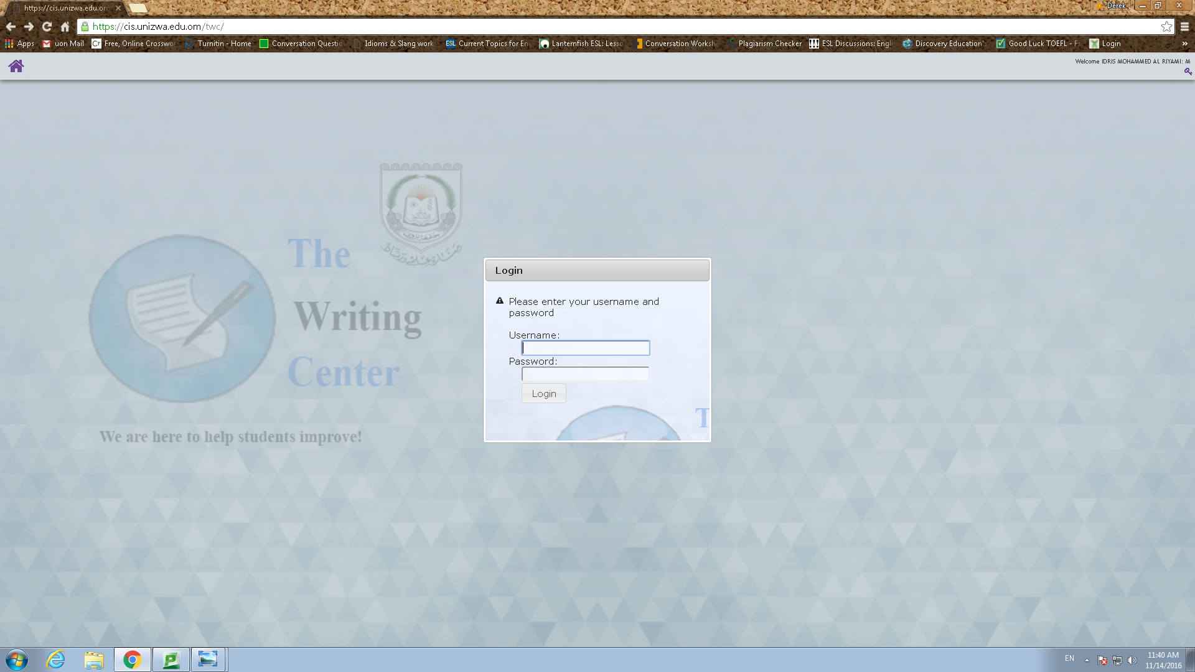
Step 2: Homepage
From the homepage, visitors can view an official record of their appointments, reserve a new appointment, upload supporting materials, and view TWC’s Arabic and English Lab timetables related to all programs and services offered by TWC.
- To make an appointment at TWC click the box “Appointment Booking”.

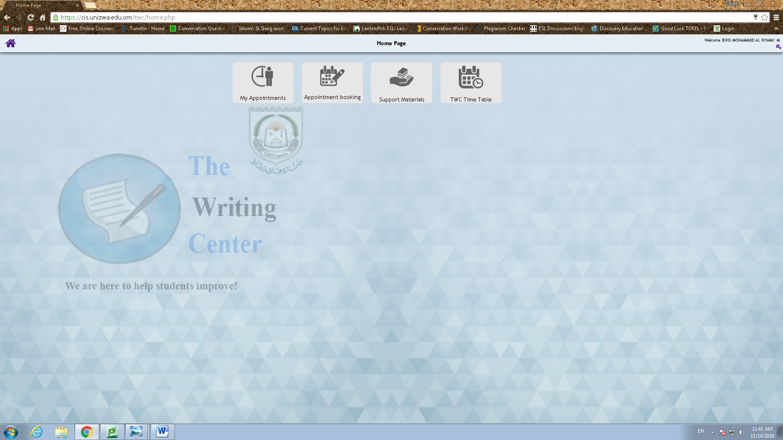

Step 3: TWC Language Labs
- Select “Arabic Lab” if you require academic support in courses taught in Arabic or require assistance with translation from Arabic to English.
- Select “English Lab” if you require academic support in courses taught in English, French, or German.
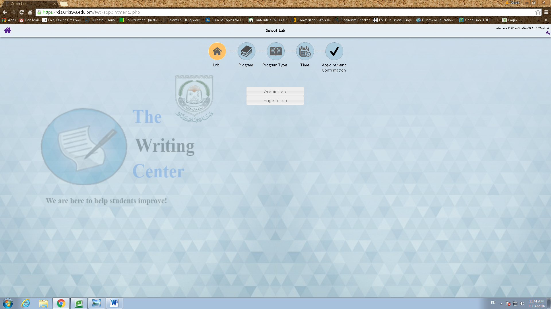

Step 4: TWC Programs and Services

- Select “Peer Tutorials” if you require one-on-one academic support with a peer mentor related to:
- Review of course material
- Mid-term & final examination preparation
- Assistance with assigned readings and homework
- Writing Practice
- Reading Practice
- Vocabulary Practice

- Select “Workshops” if you intend to join a small group of learners that seek academic assistance related to:

- IELTS/TOEFL Writing Practice
- IELTS/TOEFL Reading Practice
- Technical Writing Practice
- German Reading, Writing, & Speaking Practice

- Select “Academic Consultations” if you require assistance with the writing process related to academic assignments and research.

- Prewriting Tasks: Narrowing Topics, Brainstorming, Outlining
- Drafting & Revising
- Document Format & Style
- APA Referencing & Citations
- Paraphrasing & Summarization
- Review of Course Materials
- Presentation Preparation

- Select “Conversation Sessions” if you require assistance with oral communication skills related to”
- English
- French
- German

- Select “Extracurricular Activities” if you wish to participate in the following:
- TWC Annual Essay Contest
- TWC Book Club
- Korean Cultural Group

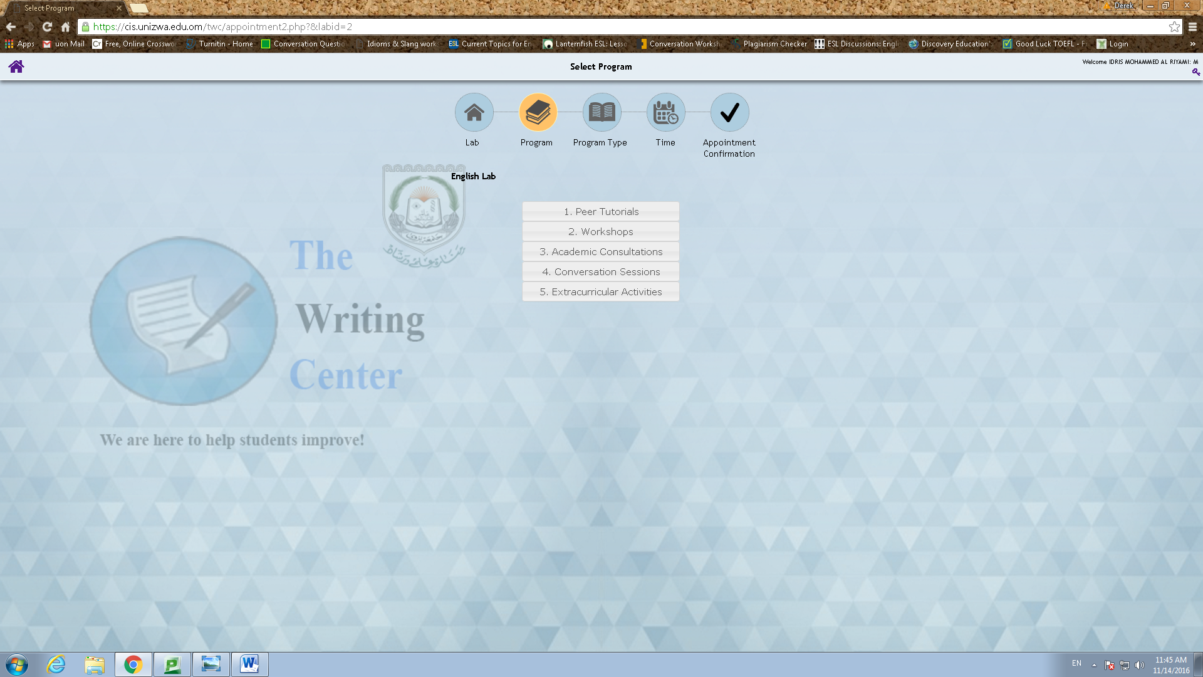
Step 5: Type of Program
- Select the type of service required for the program that you have previously chosen in step 4.
- This is an example of the drop down menu for a selected peer tutorial.
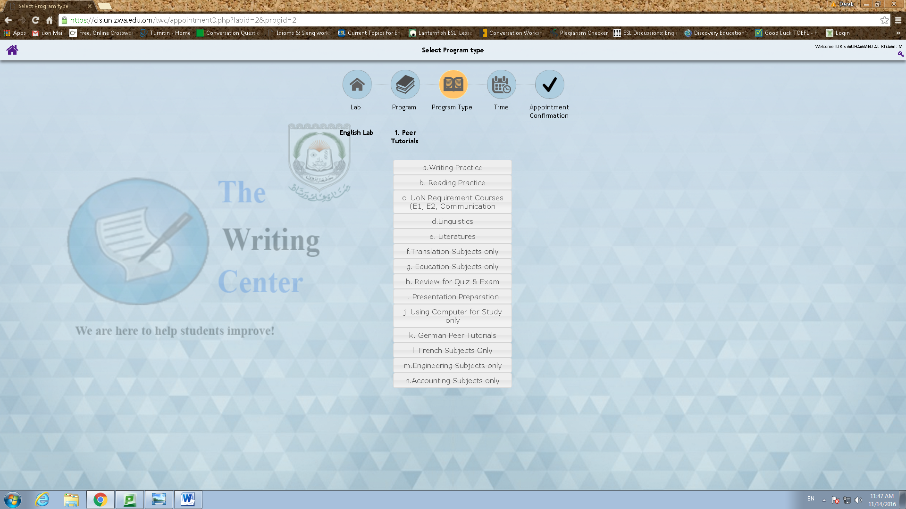
Step 6: Appointment Scheduling
- Select the date and time of your appointment. (Grey = Not Available Gold = Available)
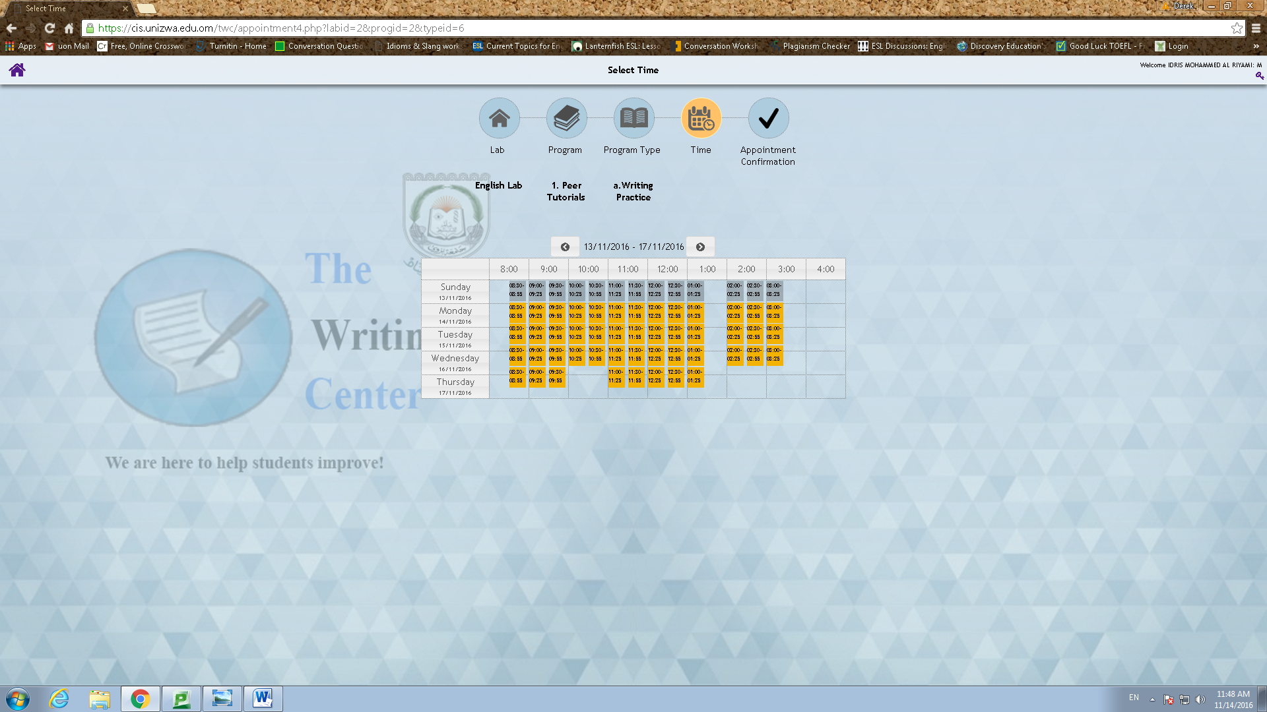

Step 7: Confirmation Booking
- Confirm your proposed appointment booking.
- Read the Rules for Students Visiting TWC and select the box.
- Select “Register”.
(Lab, type of appointment, type of service, date, and time)
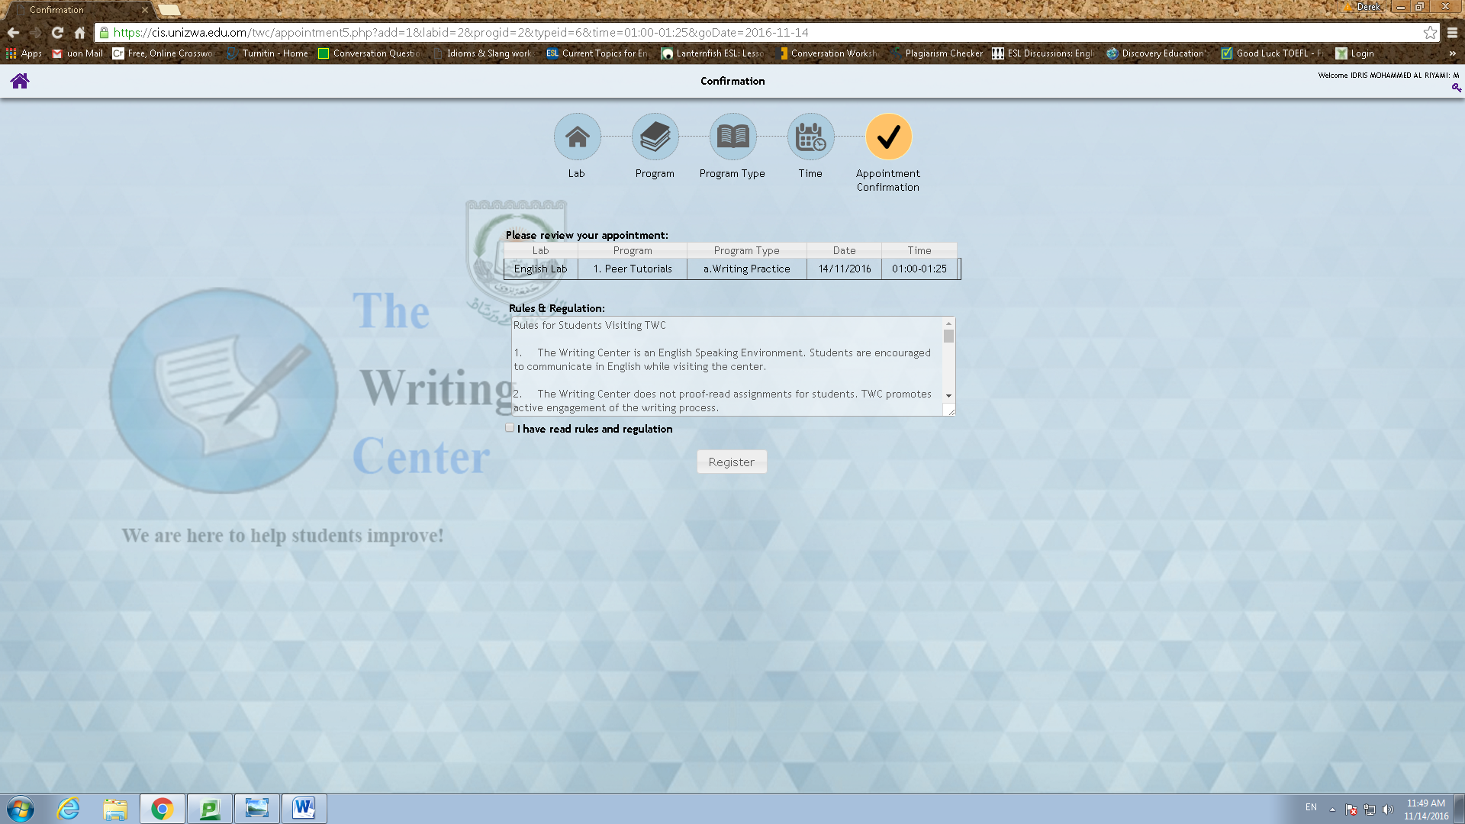

Step 8: TWC Appointment Reserved
- Your appointment has been successfully reserved at TWC.
- An automated email has been sent to you as a reminder of your appointment at TWC.
- Kindly logout on the upper right corner or make another appointment.
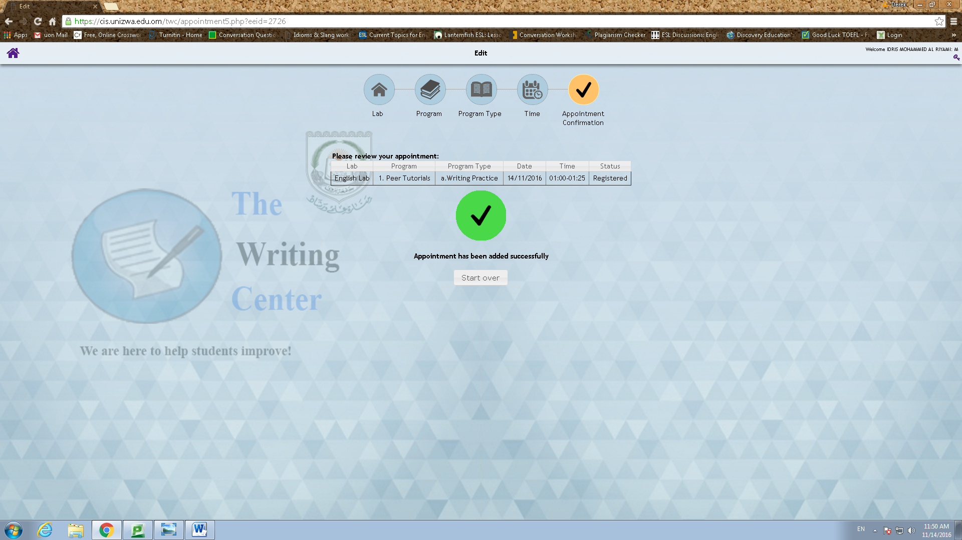

Appendix 1: Student Appointment Record and Cancellation Process
- Click on the Homepage box labeled “My Appointments” to view an official record of the appointments that you reserved and attended at TWC. This information is practical for students that need to provide evidence to their academic advisors or course instructors that the student has successfully sought quality academic support.

- If you are not able to keep your reserved appointment for any reason, kindly cancel the appointment from this page at least one hour before it is scheduled to start. Failure to responsibly cancel appointments twice (2) in a month will result in temporary blockage of your account.

- Please visit in person to have your account unblocked for future usage.

- Select the “X” to cancel previous scheduled appointments.

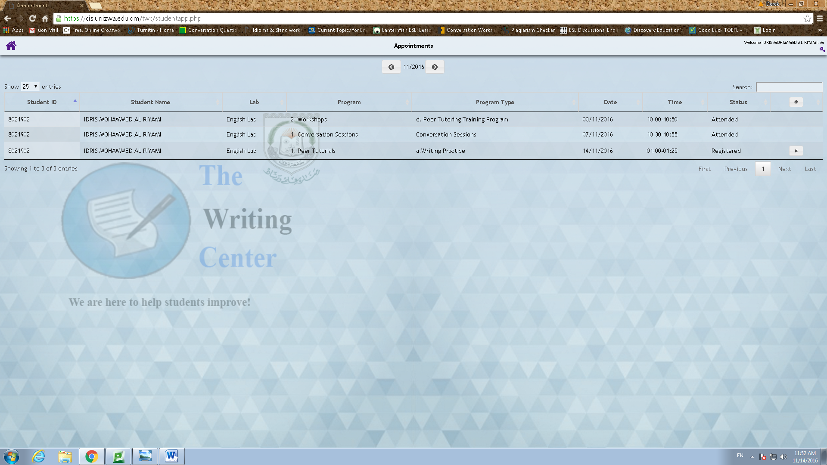

Thank you for visiting TWC

